
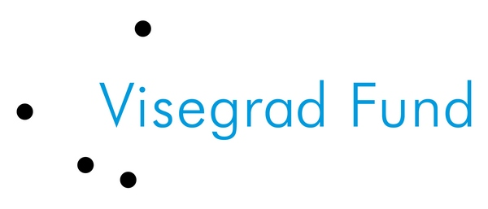
The event is organized under the project
“Preventing waste production – an essential step
towards sustainable V4 region“, which is supported by
International Visegrad Fund.

Friends of the Earth – SPZ
invite you to the expert conference

“How to prevent waste ?“

When: 19th October 2011, 8:30 am – 3:45 pm
Where: Hotel Barónka, Mudrochova 2, Bratislava – Rača, Slovakia
At whom is the conference aimed:
At specialists in public administration, higher regional units, local authorities, waste disposal companies, technical services, producers, but also broader expert community interested in waste management.
Conference objective:
To start a long-term expert discussion on waste prevention in Slovakia by involving broader expert community, the outcomes of which will be very precious in preparing the waste prevention programme in the Slovak Republic.
Conference programme:
8:30 – 9:00 am | Registration
9:00 – 9:10 am | Opening speech (Martin Valentovič, Friends of the Earth - SPZ, Slovakia)
Section I. | Political and legal basis
9:10 – 9:50 am | Policy and instruments for waste prevention at EU level (Stephanne Arditi, EEB, Belgium)
9:50 – 10:20 am | The waste prevention programme in the Slovak Republic – state of preparation  (Ing. Elena Bodíková, PhD., The centre of waste and environmental management, Slovak environmental agency, Slovakia)
10:20 – 10:40 am | Break
Section II. | Approaches to the topic in European regions
10:40 – 11:40 am | Legislative situation in municipal waste prevention in the Czech Republic (Ivo Kropáček, Hnuti DUHA, Czech Republic)  Examples of waste prevention in Czech towns and municipalities (Petr Nohava, Hnuti DUHA, Czech Republic)
11:40 – 12:10 pm | Current situation of waste prevention in Hungary (Zsuzsa Portik-Bakai, HuMuSz, Hungary)
12:10 – 01:15 pm | Lunch break
01:15 – 02:00 pm | An Austrian model for the reuse perspective (Sepp Eisenriegler, R.U.S.Z. and RepaNet, Austria)
02:00 – 03:00 pm | Options and examples of municipal waste prevention in Slovakia (Branislav Moňok, Friends of the Earth - SPZ, Slovakia)
03:00 – 03:45 pm | Final discussion and closing (Martin Valentovič, Friends of the Earth - SPZ, Slovakia)
Organizational remarks:
The conference will be held in the Slovak as well as the English language with simultaneous interpreting. Participation at the conference is FREE. However, the number of places is limited, therefore it is necessary to register by phone, or send a registration form by email or fax to M.Eng. Ján Vozár - email: vozar@priateliazeme.sk, telephone number: 0904 241 758 or fax: 055 / 677 1 677. The organizers reserve the right to limit the number of representatives of one organization if necessary due to capacity.

- - - - - - - - - - - - - - - - - - - - - - - - - - - - - - - - - - - - - - - - - - - - - - - - - - - - - - - - - - - - - - - - - - - - - - - - - - -

Registration form for the expert conference
“How to prevent waste production?“
on 19th October 2011, Hotel Barónka, Bratislava

First name ...............................................................................................................................................

Last name ...............................................................................................................................................
Town / Company ...................................................................... Position .....................................................
Postal address .....................................................................................................................................................
Tel./Fax ..................................................................... E-mail ...........................................................................

I will / I will not have lunch.
I prefer meat / vegetarian dish for lunch.
(Please, cross out what does not apply.)

